**IO3.A – Community of Practice Guideline**

# Access

Once logged in:

* the community for lecturers is available at <https://teacher-mathe.pixel-online.org>
* the community for student is available at <https://student-mathe.pixel-online.org>

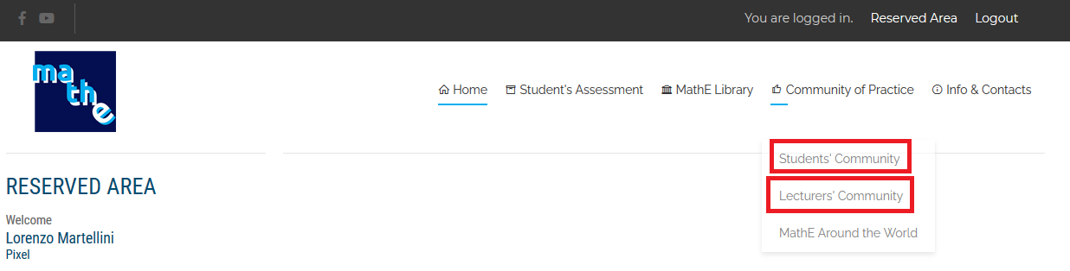

# Users

Users in the community have different permissions according to the group(s) they belong to. The groups are:

* **Admins**: they have complete access to the administration panel, full powers in moderating the discussions, can suspend users and participate in all discussions
* **Moderators**: they have full powers in moderating the discussions, can suspend users and participate in all discussions
* **Lecturers**: they can participate in all discussions
* **Students**: they can read the discussion

# Discussions

## Topics

The 4 main discussions of the lecturers’ community are:

* Experiments using MathE
* Motivational tips in Math Subjects
* Scientific publications in Math Educational Math teaching tools
* Activities using active based learning
* Tools for online teaching

The main discussions of the students’ community are the math topics of the project.

## Open a discussion

Moderators and Admins can start new discussions without authorization.



All registered lecturers can start a new discussion in the community, but before it being visible to the entire community, it has to be approved by a moderator or an admin.

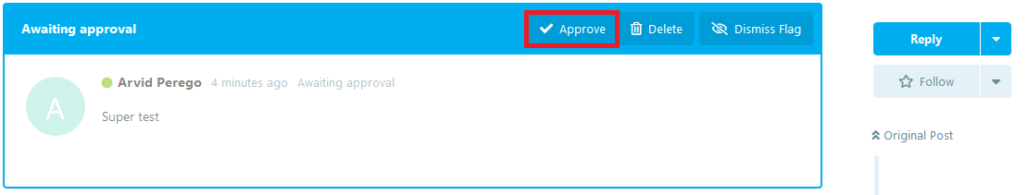

Students cannot start a discussion.

## Participate in a discussion

All community members can participate in a discussion by clicking on “Write a Replay” and make use of menu at the bottom of the box. It is possible to insert function. The language is KateX, an extention of LateX.

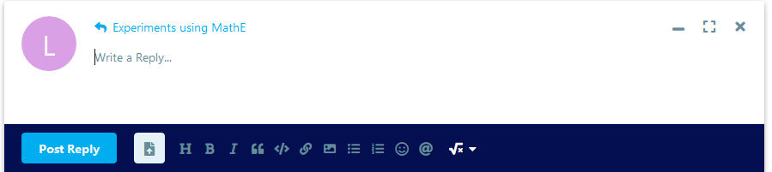

# Tags

Tags allow the users to categorize the discussions.

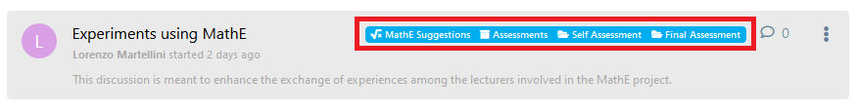

Tags are assigned by the creator of the discussion, but they can be modified by admins and moderators.

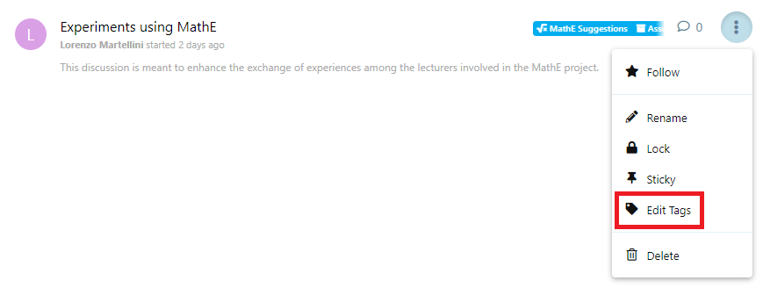

The list of available tags can be edited only by the admins.

# Search Engine

The search engine allows to search both in the discussions and among the users:

* Discussions are searched by entire words
* Users by single letters

